**JANUARY 30, 2017 – NOON**

**OHIO VALLEY EMPLOYMENT RESOURCE**

**COUNCIL OF GOVERNMENTS MEETING**

**LORI’S RESTAURANT, CALDWELL, OHIO**

**Minutes**

**Attendance:**

Carl Davis, Monroe County Commissioner

Tim Price, Monroe County Commissioner

Mick Schumacher, Monroe County Commissioner

Mike Reed, Morgan County Commissioner

Adam Shriver, Morgan County Commissioner

Tim VanHorn, Morgan County Commissioner

Ty Moore, Noble County Commissioner

Virgil Thompson, Noble County Commissioner

Gary Rossiter, Noble County Commissioner

Ron Feathers, Washington County Commissioner

Rick Walters, Washington County Commissioner

David White, Washington County Commissioner

**Others in Attendance:**

Herman Gray Jr, WDB Chair

Jeanette Harter, Director, County Department of Job & Family Services

Vicki Quesinberry, Director, Morgan County Department of Job & Family Services

Heidi Burns, Morgan County Department of Job & Family Services

Ginger Bowen, Morgan County Department of Job & Family Services

Mindy Lowe, Director, Noble County Department of Job & Family Services

Tom Ballengee, Director, Washington County Department of Job & Family Services

Candy Nelson, Washington County Department of Job & Family Services

Kathy Lott-Gramkow, Washington-Morgan Community Action

Rebecca E. Safko, Executive Director, Ohio Valley Employment Resource

Michelle Hooper, Grant Assistant, Ohio Valley Employment Resource

1. THE PLEDGE OF ALLEGIANCE TO THE FLAG was led by Virgil Thompson.
2. DRAFT MEETING MINUTES of the October 24, 2016 Meeting **COG 15-16 Motion to accept the minutes as read. Motion by: David White; Second by: Mike Reed. Motion passed.**
3. MONROE COUNTY SUCCESS STORY – GUEST HEATHER CECIL who presented in person. Heather now works for GMN Community Action in a youth CCMEP subcontractor capacity.
4. WIOA AREA #15 ACTIVITIES
   1. Expenditures as of 12/31/16 were presented and discussed. Overall 29.31% spent.
   2. OVER budget revision & line item expenditures as of 12/31/16 was presented and discussed. It contained 3 new budget items:
      1. Approval for Contract – Bob Haas (former state employee)
      2. Approval for Training – “Lunch and Learn”
      3. Approval for One-stop operator transition

The Commissioners requested more detailed information before passing these new items and they were tabled with the balance of each going to uncommitted.

**COG 16-16 Motion to accept the $826,870 budget that was handed out, but to table the 3 new items, moving them to uncommitted. Motion: Mike Reed; Second by: Rick Walters. Roll call vote was held (Commissioner Schumacher was out of the room) 3 opposed: Commissioners: Feathers, VanHorn and White. Motion passed.**

* 1. Make It In America Allocation $1,299,956.00

As of 12/31/16: Total Accruals/Expenditures $976,781.52

Total Obligations           $120,237.67

Unobligated balance $202,936.81

D. National Emergency Grant - #28 Sectors - 7/1/2015 - 6/30/17 w/no accruals

Sectors: Polymers, Energy and Healthcare

Allocation Distribution 1st year $296,485 $250,000 to Counties $50K Mo/Mg/N; 100K W

Released to Area 16 (150,000) 53,649 to OVER

2nd year 326,485 80,000 for Regional Plan

Total Funding $472,970 $ 383,649 = balance left = $89,321 It was noted that Monroe is fully expended

**COG 17-16 Motion to allocate $50,000 to Monroe and hold the remaining $39,321 unallocated, which can be allocated to any requesting county. Motion: Gary Rossiter; Second by: Tim VanHorn. Motion passed.**

1. November 2016 Help Wanted Online Job Postings was presented and discussed.
2. [www.OMJ15.com](http://www.OMJ15.com) (under construction), but will be the new webpage.

G. Area One Stop Visitor Report was presented and discussed.

H. Washington County One-Stop Certification Updates – Visit scheduled 2/9/17

WDB Committee members: Marc Manheim, Ann Block, Misty Wells, Connie Shriver, Herman Gary

I. One-Stop Operator RFP discussion of role and timeline. The WDB rating committee members are: Jeff White, Connie Shriver, Chasity Schmelzenbach, Pam Lankford, Laura Fuller.

J. Youth Procurement requirement discussion of the federal requirement to competitively procure the youth program (framework and elements) and select based on WDB review and rating of the responses received.

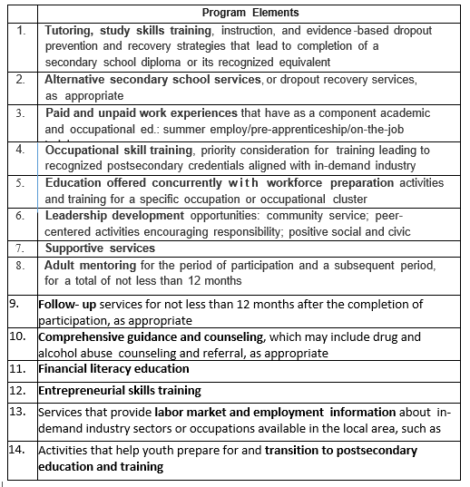

K. Approval of Financial Handbook and Procurement Handbook that was sent electronically to all members and interested parties.

**COG 18-16 Motion to approve both the Financial Handbook and Procurement Handbook. Motion: Rick Walters; Second by: Tim VanHorn. Motion passed.**

L. WIOA 16 One-Stop Assistance for Rapid Response Events

**COG Motion** **COG 19-16 Motion to accept WIOA Area 16 Monroe County One-Stop Assistance for the anticipated coal mine layoffs and other associated rapid response events. Motion: Tim VanHorn; Second by: Gary Rossiter. Motion passed.**

M. Monroe County Youth Contractors

1. GMN Tri-County Community Action

1. Providing: Adult Mentoring; Alternative Edu; Career Pathway; Comprehensive Guidance & Counseling; Entrepreneurial Skill Trng; Financial Literacy Edu; Follow-up Services; Leadership Development; Occupational Skills Trng; Paid & Unpaid Work Experience; Provision of Labor Market Info; Supportive Services; Transitional Skills; Tutoring, Study Skills & Drop-out Prevention; Contract period: January 4, 2017 to June 30, 2017; Amount: $75,000 of which 50,625 is CCMEP TANF; 5,625 CCMEP TANF ADMIN; 1,8750 CCMEP WIOA youth.

2. Mid-East Career Center

1. Providing: Career Pathway; Entrepreneurial Skill Trng; Financial Literacy Edu; Leadership Development; Provision of Labor Market Info; Transitional Skills; Contract period: January 4, 2017 to June 30, 2017; Amount: $12,080 of which 9,060 is CCMEP TANF and 3,020 CCMEP WIOA youth
2. WORKFORCE DEVELOPMENT BOARD MEMBERS
   1. Upcoming vacancy- Business, Monroe County. Janelle Comstock (Monroe) WDB member has accepted a new position as WDB Director for the Parkersburg, WV WDB (Congratulations Janelle!). Unfortunately, when notifying the State of this change, the state decreed we must nominate the new Chamber President or another Monroe County business representative.
   2. Resignation of Kim Stewart (Morgan)
   3. New Appointee – Morgan County, Tonya Kohler, Human Capitol Mgr, MIBA Sinter USA, LLC

**COG 20-16 Motion to appoint Tonya Kohler to the WDB. Motion: Tim VanHorn; Second by: Gary Rossiter. Motion passed.**

1. STATE & REGIONAL PLANNING UPDATE – Herman Gray, Jr, Workforce Development Bd. Chair
   1. Summary of the Governor’s Office of Workforce Transformation’s “Building Ohio’s Future Workforce.” The full document was sent in advance to all members and interested parties. WDB Chairman, Herman Gray summarized the report and linkage to the local area.
   2. Area businesses surveyed:

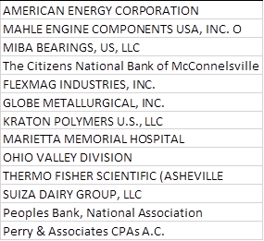

* 1. Regional Workforce Plan Update – Comparison of State & Regional Visions was presented and discussed.
  2. Timeline for Southeast Ohio Regional Plan:

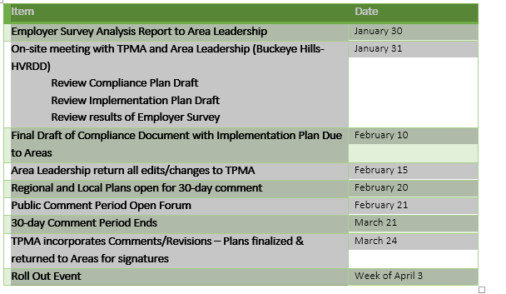

1. NEXT MEETING DATE WAS CHANGED from ~~Monday, May 1, 2017~~ to Monday, March 27th at Noon at Lori’s Restaurant for RFP timetables.
2. ADJOURNMENT **COG 21-16 Motion to adjourn. Motion: Tim VanHorn; second: Gary Rossiter. Motion passed.**

**Approved By: _________________________________ Date: __________________**

COG Chair or Vice Chair