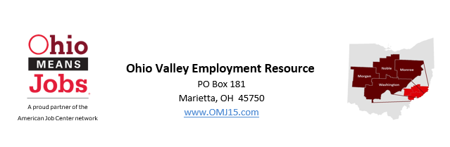

You have been identified as a workforce leader in our community and I am reaching out to you regarding a possible opportunity to help improve our employment and training opportunities locally by becoming a Workforce Development Board member.
Workforce Development Boards serve contiguous counties with shared educational institutions, commuting patterns, and/or industry sectors. The Board is federally required to be business driven with a majority of the membership and the Chairperson representing local business. Our area consists of Monroe, Morgan, Noble and Washington counties. Our organization is named Ohio Valley Employment Resource.
As a Workforce Development Board member, you will be identifying successful strategies to improve our workforce and thus our economy by:
Reviewing local OhioMeansJobs (OMJ) centers and contracts for operational efficiency and making recommendations for improvement.
Engaging community members to partner with and/or utilize the free services that we provide to help the job seeker find employment or improve employability skills on their career path to self-sufficiency.
Developing solutions for local employers to help with their workforce needs: finding the right employee; retention; upskilling their existing workforce – the possibilities are extensive and can be tailored to the employer.
Identifying local service providers to connect with youth and provide a variety of services to help the youth transition into the workforce.
Learning about the existing system and workforce challenges to grow our potential.
These are just a few of the topics. As a member, you would be expected to attend quarterly meetings. These meetings generally are at Lori’s Family Restaurant in Caldwell for approximately two hours. Attendance is important as a majority is required to conduct business. (Quorum options exist if you are prevented from attending occasionally.) In addition, based on your areas of interest and expertise, you will be asked to engage in special committees for a more intense focus on: youth, OMJ centers, local strategy, special projects, etc. These committees are generally a short term commitment (2-4 meetings possibly in person and/or via phone w/associated emails) to focus, learn, evaluate and report back to the full board with a recommendation.
Please consider the opportunity, check out our website at: https://www.omj15.com/workforce-development-board. I look forward to working for you as staff to the Board and answering any questions you may have!

Respectfully,

Rebecca Safko, Executive Director
Rebecca@omj15.com
740-632-4671

